[DOC-3131](http://jira.pentaho.com/browse/DOC-3131): Create process documentation for image handling in MindTouch

# Adding Images to MindTouch Articles

The images used in MindTouch articles should be informative, limited in number, and focused in scope. Import an image into MindTouch when it makes sense to represent something visually rather than textually. Do not show a configuration file, options screen, or communicate important textual information.

Perform the following steps to add an image to a MindTouch article:

1. Create the condition in the software or the tool that you want to capture.
2. Open Snagit and grab a screen capture (see Setting Up Snagit).
3. Use the drag handles to crop the capture area and then click the **Capture Image** button.
4. If needed, use Snagit Editor to annotate the image’s area(s) of interest per the following style guide requirements:

* Arrows
* Blur
* Borders
* Boxes
* Callouts
* [Edge Effects (Fade)](#_Edge_Effects_(Fade))
* Highlight Area
* Lines
* Number Labels (Steps)

1. Name and then save the image (see Image File Naming Standards and Repository for instructions). An image should be saved as .png file in the central repository in MindTouch, and as a .snag file in the associated documentation story folder in Box.
2. In MindTouch, select **Edit** and thenplace your cursor where you want to put the image and click **Enter**. If inserting images into a numbered list, place your cursor at the end of the list item and press **Enter** twice.

*Note: Inserting images into numbered lists breaks the numerical order.*

1. In the MindTouch edit toolbar, click **Image**. The **Image** window opens and the **Search** tab is shown by default.
2. Click the **Attach** **files** tab.
3. Click the **Choose Files** button then browse to the image file that you want to add to the article. After the image is uploaded, MindTouch switches to the following **Options** tab:

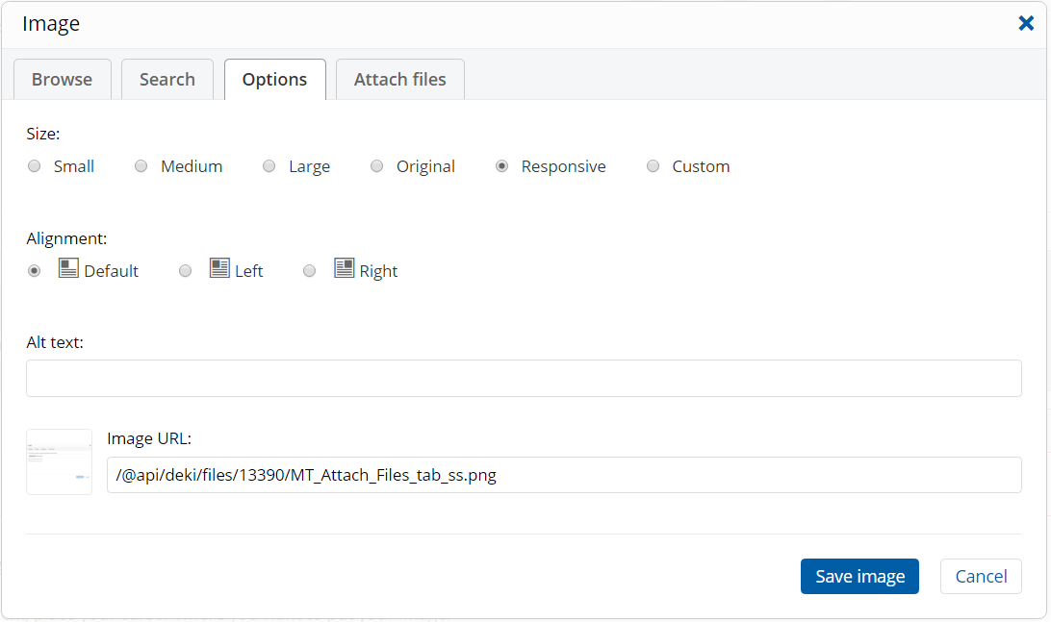

1. Select **Responsive** for the **Size** setting and ensure that **Default** is selected for the **Alignment** setting.
2. Add **Alt text**, if needed, and then click the **Save image** button.

After you save the MindTouch article, your image will appear on the page.

# Annotation Guidelines

Use the Snagit Editor to add annotations to images. The following annotation guidelines, based on previous use cases and Pentaho branding guidelines, should be followed. See Setting Up Snagit for the specific annotation settings.

## Arrows

Arrows are used to point out text and other elements in a screen capture. When used with a callout or box, the arrow should be aligned "behind" the callout or box. Use the zoom on the image to check the alignment. Different types of arrows are used depending on the use case:

* **Equilateral Arrow**: The standard arrow used for annotation.

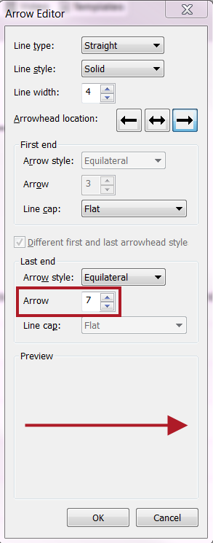

* **Barbed Arrow:** A floating arrowhead that can be useful when real estate is limited, for example, to point out a small UI element or one field among many. Use with discretion.

## 

## Blur

Blur can be useful to obscure information deemed too restrictive for all users, too sensitive for any user, or where the information distracts from the intent conveyed in the image.

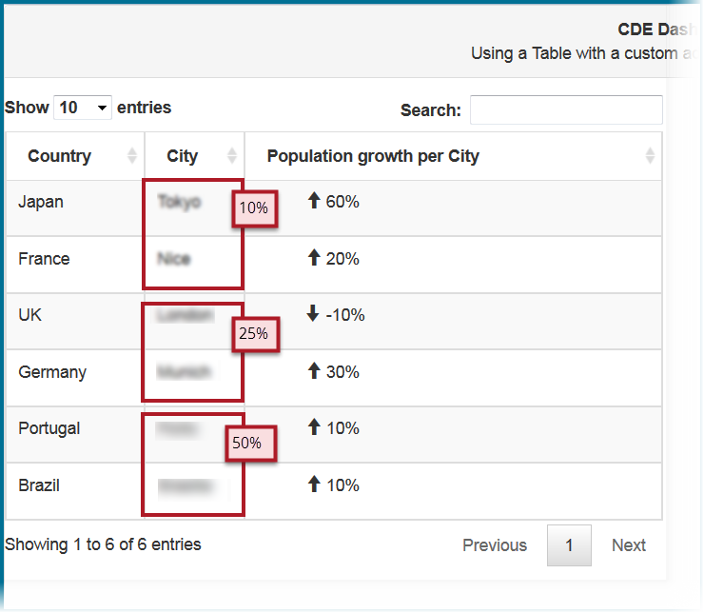

## Borders

Borders can help define an image for the reader by clearly delineating the visual reference.

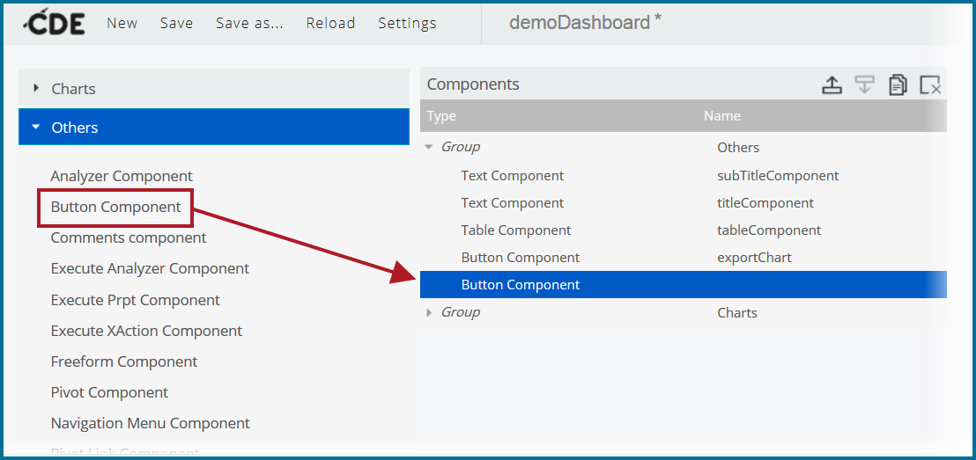

## Boxes

Boxes are useful shapes for highlighting UI elements indicated in a task step or an overview description.

## Callouts

Callouts are a combination of text and graphics that present key information, useful for consolidating information in a single screen capture. Callout text can be words, phrases, or sentences. Callout graphics can be used in conjunction with an arrow and should be placed within a screen capture, only extending past the border if necessary. Do not use callouts to repeat information in the documentation, but rather to present a tip, an example, or a concise statement regarding the item(s) of interest.

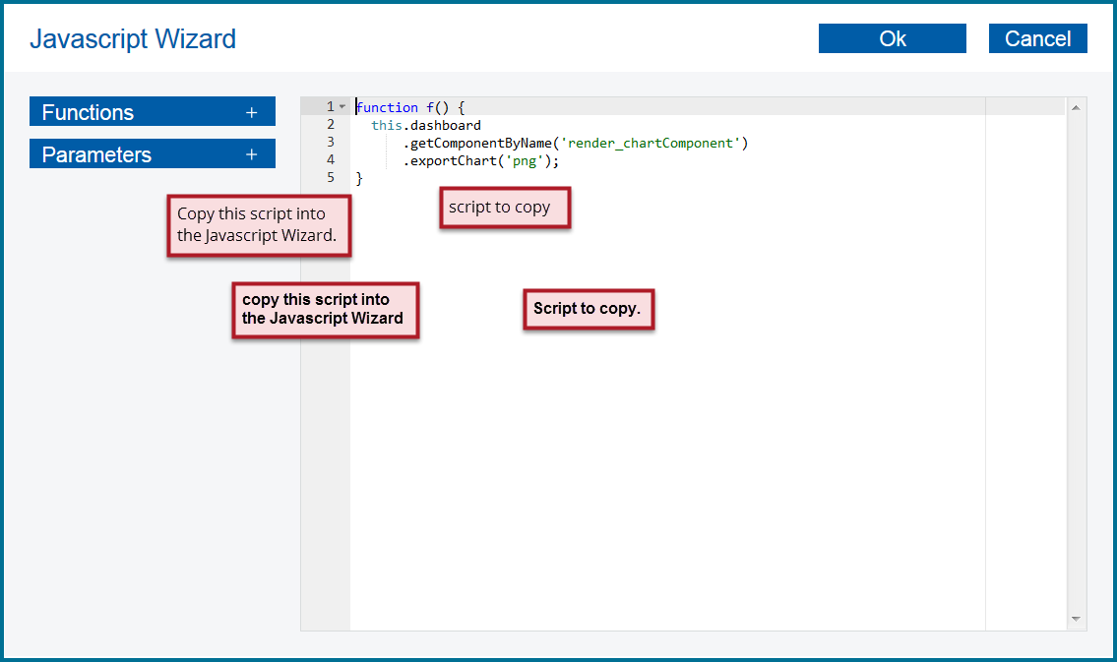

## Edge Effects (Fade)

Edge fading can be used to indicate that you are showing only part of a screen, dialog box, or window.

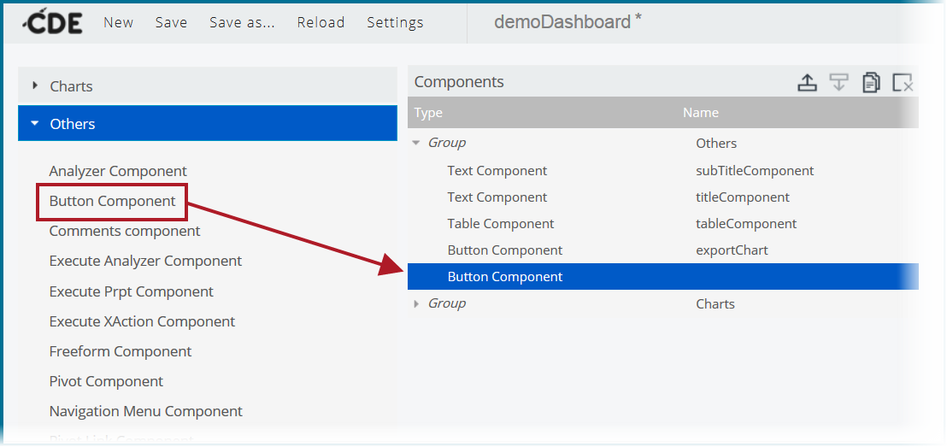

## Highlight Area

Highlighting is useful for emphasizing text or multiple elements on a screen capture without overloading the image.

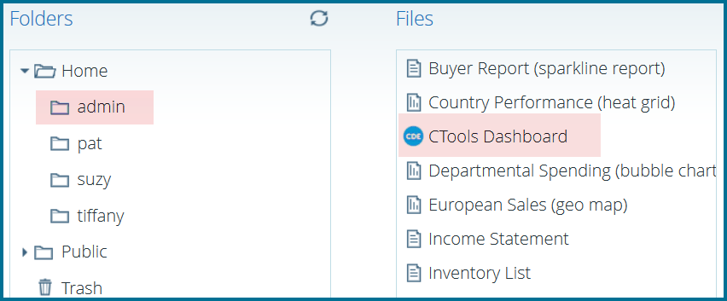

## Lines

Lines are commonly used to connect boxes and callouts.

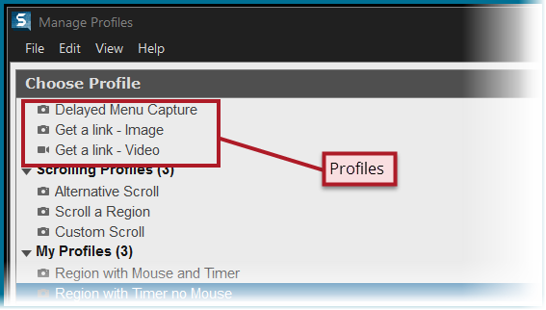

## Number Labels (Steps)

Number labels, useful in conjunction with a table, allow you to numerically identify elements in a screen capture.

|  |  |
| --- | --- |
| **Label** | **Location** |
|  | Dashboard Title Bar |
|  | Dashboard Table |
|  | Dashboard Chart |
|  | Export Chart Button |

